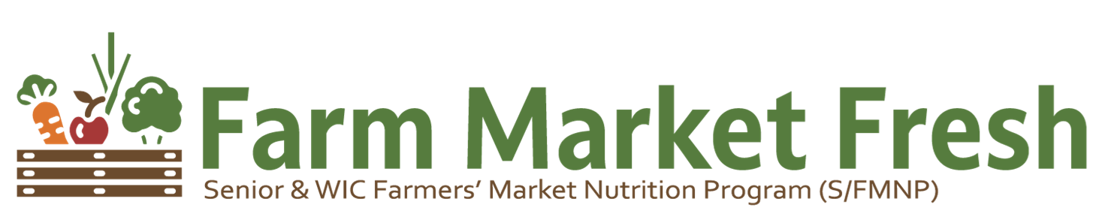

What is the Farmers’ Market Nutrition Program (S/FMNP)?

In Virginia, we call it Farm Market Fresh! Virginia’s Farm Market Fresh program helps eligible seniors get fresh, tasty, and nutritious locally grown fruit, vegetables, and cut herbs. The program also supports local farmers and farmers’ markets in Virginia.

The Virginia Department for Aging and Rehabilitative Services-Office for Aging Services (DARS-OAS) partners with the Virginia Department of Agriculture and Consumer Services (VDACS), ten local Area Agencies on Aging (AAA), and one city government to operate the program which is funded by the US Department of Agriculture, Food and Nutrition Service.

Who is eligible?

If all of the statements shown below are true, then you may be eligible to participate.
- You are 60 years of age or older.
- You are a resident of a locality that participates in the program.
- You do not live in the same household and you are not an immediate family member of the farmer who grows the produce.
- You meet the program’s income requirements. You must certify your household income.

How does it work?

- You must complete an application each year through your local Area Agency on Aging to determine if you are eligible to participate in the program.
- Participation is limited and applications are accepted on a first come-first served basis.
- Not all localities within the area served by your local Area Agency on Aging may be eligible to participate in the program.

What is provided?

- If your application is approved, you will receive $50.00 worth of checks per eligible senior for that growing season.
- Each check is worth $5.00 and may be used to purchase fresh, locally grown fruit, vegetables, and cut herbs from participating certified retail farmers market vendors. *Please note: change cannot be given if the entire $5 is not used.
- Certified retail farmers market vendors will accept checks for fresh, locally grown fruit and vegetables in-season, depending on the produce items available.

Where does Farm Market Fresh (S/FMNP) Operate?

Find the map of Authorized Farmers at participating markets here: https://vafma.org/virginia-markets/

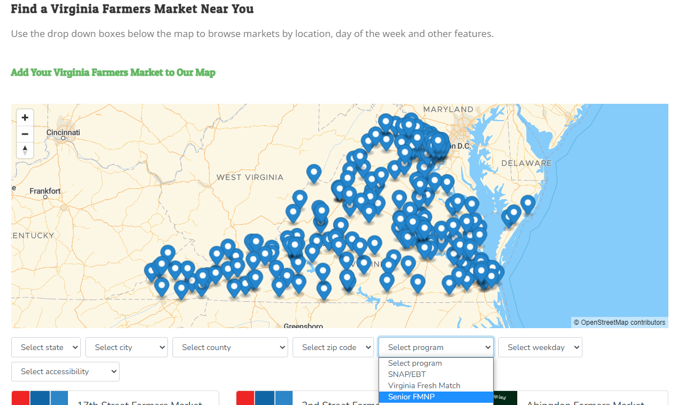

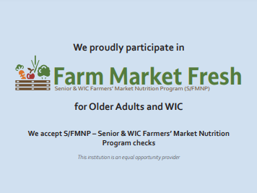
Look for this sign posted at authorized Farmers’ stands!

What’s in season?
Farm Market Fresh checks are issued for the summer growing season and usually must be spent during the months of June through November, depending on availability of produce.

Checks are used only for typical fruit and vegetables that grow in Virginia and may be found at Virginia’s retail farmer’s markets in a normal season, such as those listed below. The varieties, volume, and quality of available produce may vary depending on the weather and other factors.

VEGETABLES
Broccoli
Cabbage
Cucumbers
Eggplant
Greens
Green beans
Green peppers
Lima beans
Mushrooms

Pumpkins
Potatoes
Spinach
Squash
Sweet corn
Sweet potatoes

FRUIT
Apples
Blackberries

Cantaloupe
Nectarines
Peaches
Pears
Strawberries
Tomatoes
Watermelons

OTHER PRODUCE
Fresh cut herbs

ITEMS NOT ELIGIBLE
Items that you may NOT purchase with the SFMNP checks include:
- produce that is not locally grown such as oranges, bananas, and pineapples
- processed foods such as honey, maple syrup, cider, nuts, meat, bread, and cheese
- non-food items such as flowers and plants are NOT eligible
- dried herbs and teas

For More Information, Contact:
Virginia Department for Aging and Rehabilitation Services – Office of Aging Services
1610 Forest Avenue, Suite 100
Richmond, VA 23229
Toll-free: 1-800-552-3402 or Richmond: 804-662-9319
E-mail: aging@vda.virginia.gov Web Site: vda.virginia.gov/FarmMarketFresh

In accordance with federal civil rights law and U.S. Department of Agriculture (USDA) civil rights regulations and policies, this institution is prohibited from discriminating on the basis of race, color, national origin, sex (including gender identity and sexual orientation), disability, age, or reprisal or retaliation for prior civil rights activity.
Program information may be made available in languages other than English. Persons with disabilities who require alternative means of communication to obtain program information (e.g., Braille, large print, audiotape, American Sign Language), should contact the responsible state or local agency that administers the program or USDA’s TARGET Center at (202) 720-2600 (voice and TTY) or contact USDA through the Federal Relay Service at (800) 877-8339.
To file a program discrimination complaint, a Complainant should complete a Form AD-3027, USDA Program Discrimination Complaint Form which can be obtained online at: https://www.usda.gov/sites/default/files/documents/USDA-OASCR%20P-Complaint-Form-0508-0002-508-11-28-17Fax2Mail.pdf, from any USDA office, by calling (866) 632-9992, or by writing a letter addressed to USDA. The letter must contain the complainant’s name, address, telephone number, and a written description of the alleged discriminatory action in sufficient detail to inform the Assistant Secretary for Civil Rights (ASCR) about the nature and date of an alleged civil rights violation. The completed AD-3027 form or letter must be submitted to USDA by:
- mail:
U.S. Department of Agriculture
Office of the Assistant Secretary for Civil Rights
1400 Independence Avenue, SW
Washington, D.C. 20250-9410; or
- fax:
(833) 256-1665 or (202) 690-7442; or
- email:
Program.Intake@usda.gov

This institution is an equal opportunity provider.
07/25/2022

